Publishing a New Blog Post
Webflow → Frontrowmd site → CMS → Blogs · Posts go live at www.frontrowmd.com/blog/

Required fields
Every post needs all 8 of these before it can be created:
Field | What to enter
Name | Post title. The Slug (URL) auto-generates from it.
Slug | Auto-fills from Name. Lowercase, hyphenated → www.frontrowmd.com/blog/<slug>
Publish date | Date shown on the post (MM/DD/YYYY).
Author | Pick from dropdown.
Category | Pick one: Case Studies, Trust & Credibility, Clinician Validation, Conversion & ROI, Consumer Trends.
Read time in minutes | A number, e.g. 3.
Image | Header/thumbnail image — see sizes below.
Article | Full post body (rich text: headings, images, embeds).

Optional (recommended for SEO)
Field | What to enter
Sub heading | One supporting line shown under the title.
Meta Title | Google result title — usually same as Name.
Meta Description | 1–2 sentence search summary, ~150 characters.

Image sizes
- Header image: 2674 × 1308 px (≈2:1 wide). Match this — it is what existing posts use. Keep under ~500 KB; WebP or AVIF preferred.
- Images inside the Article: 1600 px wide is plenty. Compress before uploading.

STEP 01

Open the site
Log in at webflow.com/dashboard and open the Frontrowmd project (the "Business" card).
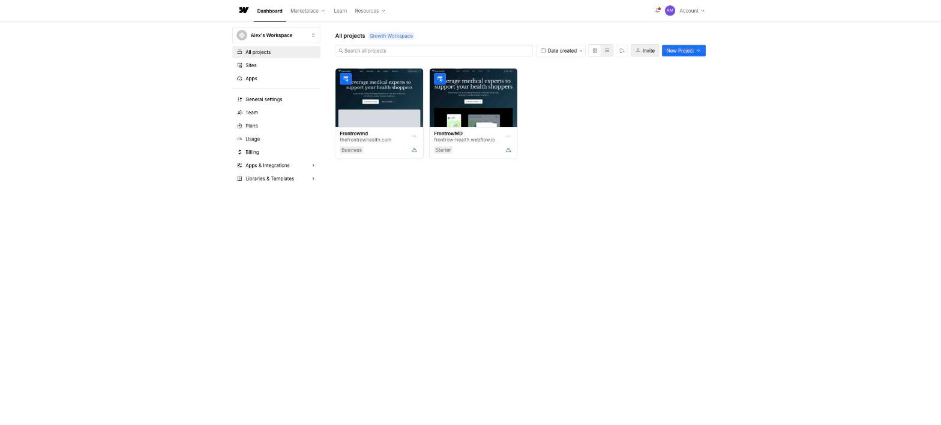
Click the "Frontrowmd" (Business) card.
STEP 02

Go to CMS → Blogs
In the Designer, click CMS (top-left), then the Blogs collection in the sidebar.
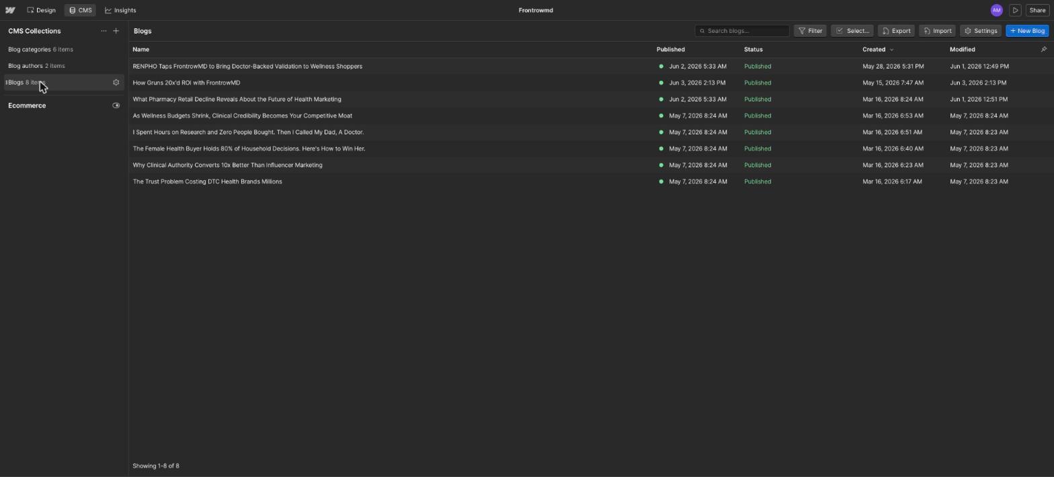
The Blogs collection — every post and its publish status.
STEP 03

Click + New Blog and fill in the fields
Click + New Blog (top-right). Fill in everything from the tables on page 1 — required fields are marked with a red asterisk in the form.
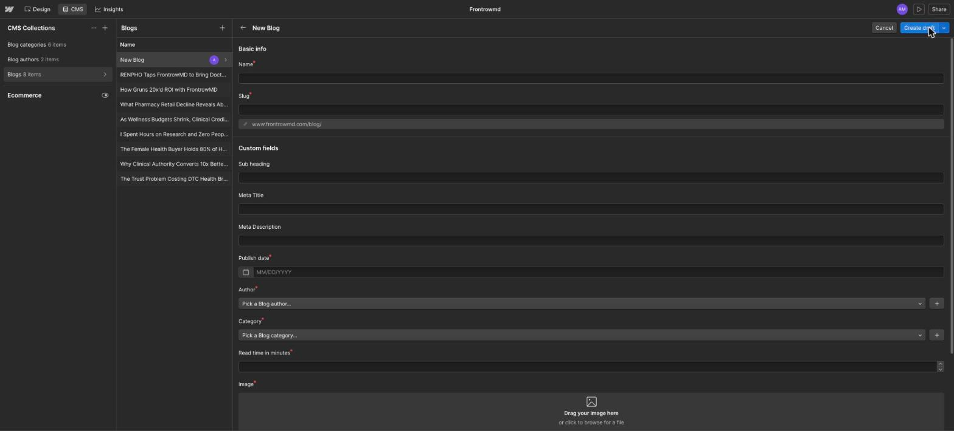
The new post form. Note the URL preview under Slug.
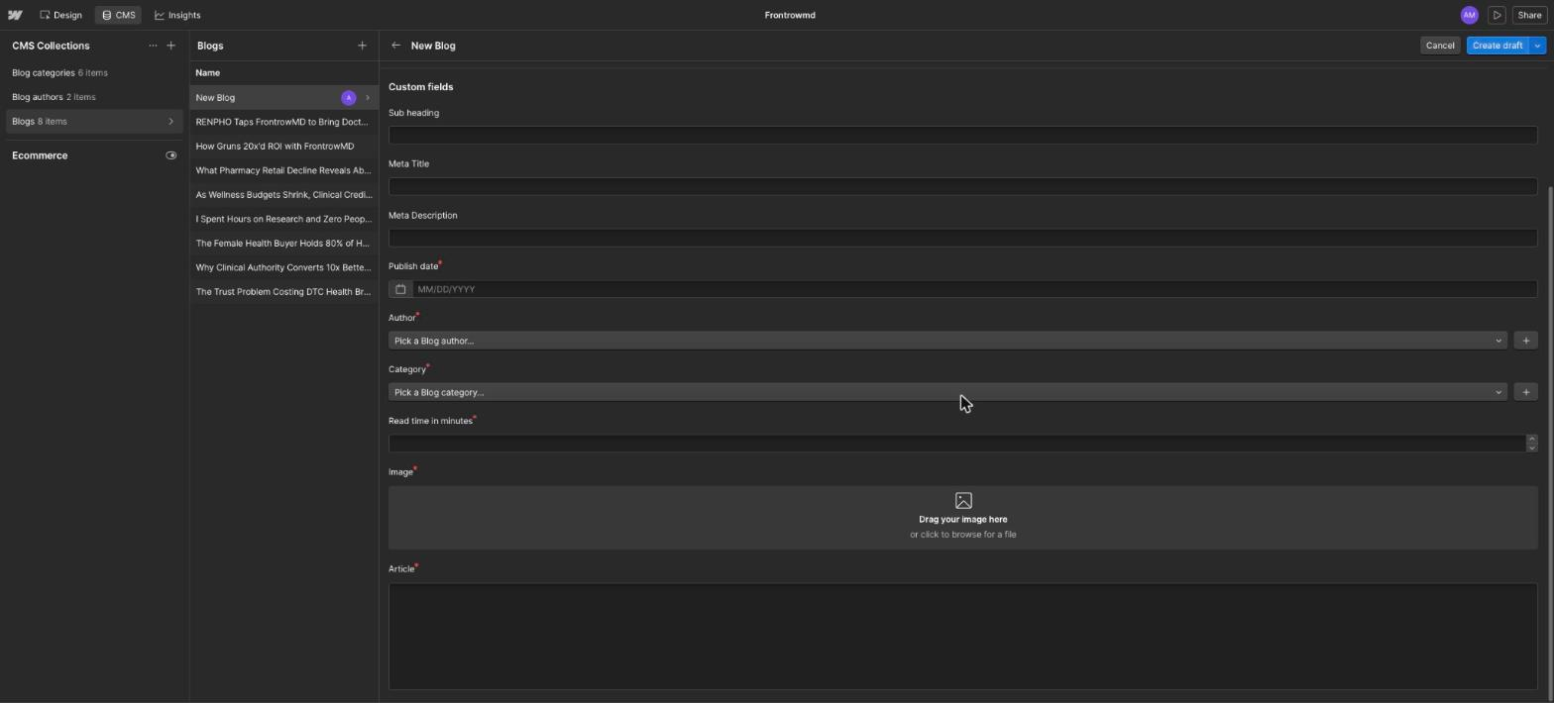
SEO fields, date, author, category, read time, image, and article body.

STEP 04

Publish the post
Top-right, click the arrow next to Create draft and pick:
- Publish now — live immediately. (The usual choice.)
- Create draft — saved but not live (needs a site publish later).
- Schedule to publish later — goes live at a set date/time.
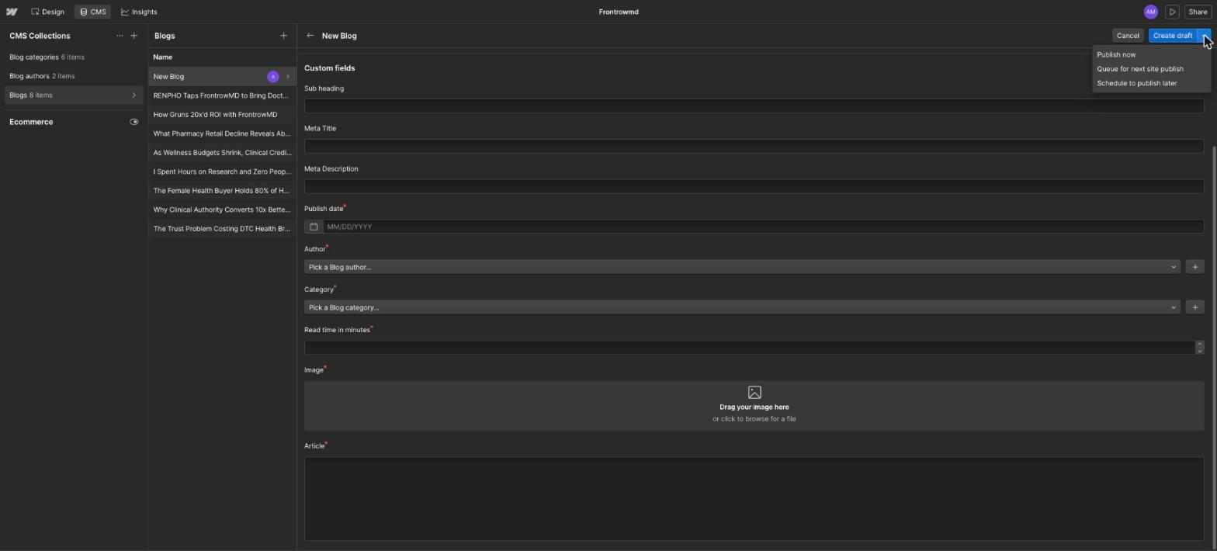
Publish options next to the Create draft button.
STEP 05

Verify
Open www.frontrowmd.com/blog — check the post appears in the listing, then open it and check images, headings, and embeds.
If it is not live: it was saved as a draft. Go to the Design tab → Publish (top-right) → check www.frontrowmd.com → Publish to selected domains. Note this pushes ALL pending site changes, not just your post.
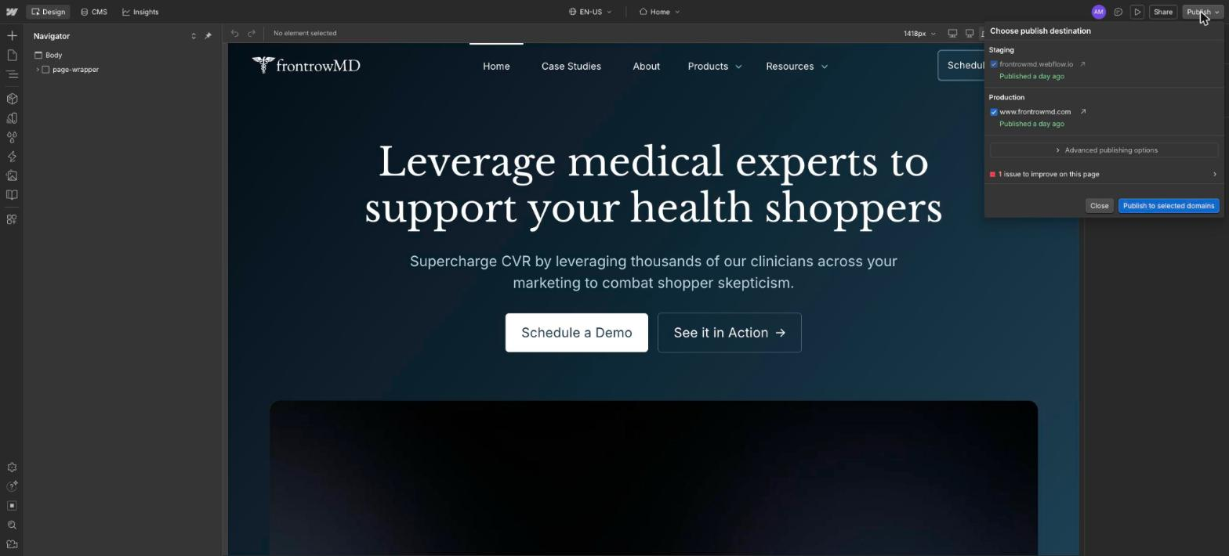
Site publish panel — only needed for drafts/queued posts.

